ŞCOALA GIMNAZIALĂ TIHA-BÎRGĂULUI
JUD. BISTRIŢA-NĂSĂUD
STR. PRINCIPALĂ, NR. 446 B
Tel./fax 0263265685
E-mail: scoalatiha@yahoo.com

EVALUARE NAȚIONALĂ LA FINALUL
CLASEI A VIII-A
RAPORTUL ŞCOLII

Examenul | Nr. de elevi participanţi
Evaluare Naţională 2013 | 31
Evaluare Naţională 2014 | 36
Evaluare Naţională 2015 | 34

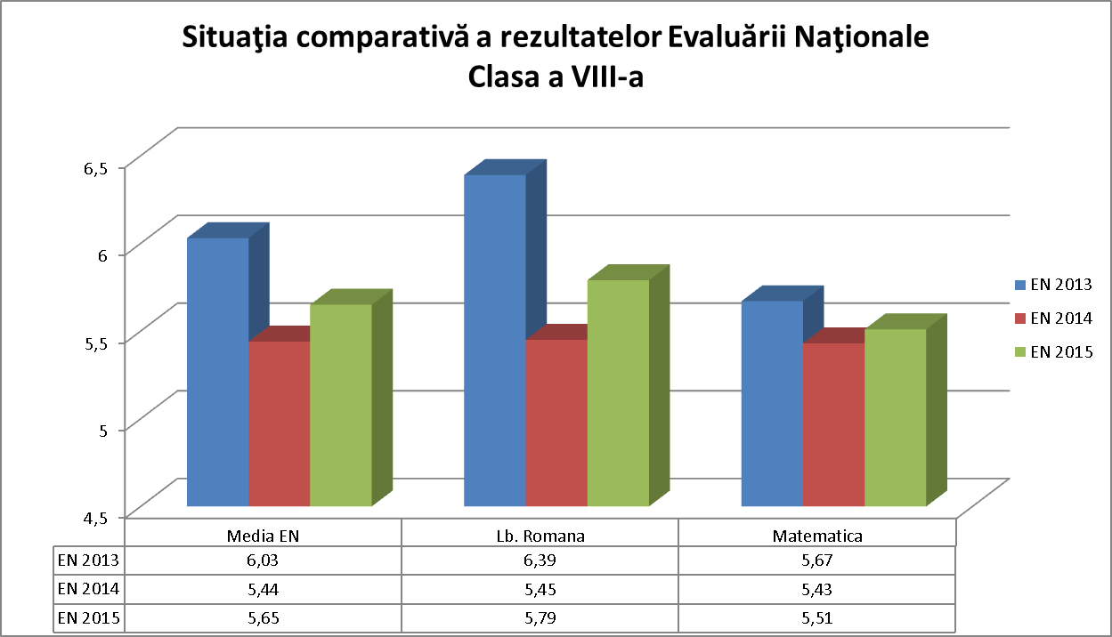

Evaluare Naţională 2013
Numele candidatului | Media EN | Lb.romana | Matematica
ATOMEI S. LOREDANA-SORINA | 4,52 | 6,05 | 3,00
BACI P. ALEXANDRA-MARIA | 6,80 | 8,50 | 5,10
BADIU I. SABINA-MARIA | 9,67 | 9,55 | 9,80
BELEI N. ANDREI-NICOLAE | 8,85 | 8,65 | 9,05
BEUDEAN I. ANTONIA-MARGARETA | 4,65 | 4,20 | 5,10
BURBULEA I. IOANA-MARIA | 9,30 | 9,10 | 9,50
CUREAN Z. ZAHARIE | 2,82 | 3,80 | 1,85
DOLOGA M. IOANA-FLORICA | 8,97 | 8,10 | 9,85
GALBEN G. GEORGIANA | 4,50 | 5,00 | 4,00
GIVAN I. IONUT-PETRU | 4,45 | 5,70 | 3,20
HANGANUT A. IONUT-TIBERIU | 6,50 | 5,70 | 7,30
HANGANUT A. LENUT-CORNEL | 6,85 | 5,50 | 8,20
MOISAN D. MIHAELA-MARIA | 5,92 | 6,85 | 5,00
PAVALEAN A. MARIA | 5,85 | 7,45 | 4,25
PETROVAN V. ALEXANDRU | 5,15 | 6,30 | 4,00
POP T. DIANA-ANASTASIA | 9,02 | 9,00 | 9,05
RUS G. GHEORGHE-MIHAI | 9,42 | 8,85 | 10,00
SOCINA T. FLORINA-IONELA-CLAUDIA | 7,72 | 6,70 | 8,75
BODASCA V. NICOLAE-FLORIN | 1,80 | 1,60 | 2,00
BOZGA I. ANASTASIA-IULIA | 3,92 | 4,00 | 3,85
CRISAN I. IOAN | 3,52 | 4,40 | 2,65
CUREA I. FLORICA-NICOLETA | 4,90 | 6,10 | 3,70
GALBEN G. GEORGIANA-MARIA | 5,50 | 6,50 | 4,50
HANGAN I. MIOARA-FLORICA | 6,10 | 7,00 | 5,20
MAJER G. ELENA-MARIA | 7,70 | 7,85 | 7,55
ONIGA G. MARIA-PETRUTA | 3,55 | 4,50 | 2,60
RINZIS G. MIHAI-GABRIEL | 4,90 | 5,70 | 4,10
RINZIS V. FLORICA | 6,80 | 6,60 | 7,00
SERETAN I. VIOREL-IOAN | 2,97 | 3,45 | 2,50
SERETAN T. ADINA | 9,52 | 9,40 | 9,65
PASERE I. ANDREEA-ELENA | 4,70 | 6,00 | 3,40

Evaluare Naţională 2014
Numele candidatului | Media EN | Lb.romana | Matematica
CIOANCA C. CATALIN-ANDREI-VASILE | 3,60 | 4,20 | 3,00
CIOARBA P. IONUT-ANDREI | 8,60 | 7,70 | 9,50
CURTEAN D. ANDREEA-MARIA | 7,15 | 5,60 | 8,70
DURA T. FLORIN-MARIAN | 5,15 | 5,20 | 5,10
GALBEN T. TEODORA-MARIA | 2,65 | 3,00 | 2,30
GIVAN I. ALINA-MARIA | 4,60 | 4,10 | 5,10
GONTARIU V. BIANCA-IONELA | 5,80 | 6,00 | 5,60
LAZARUT C. LENUTA-COSMINA | 5,55 | 5,00 | 6,10
PAVELEAN I. IONUT-ANDREI | 2,10 | 2,20 | 2,00
PAVELEAN V. IONELA | 5,57 | 5,40 | 5,75
RUS G. LIANA-GEORGIANA | 7,00 | 7,00 | 7,00
RUS T. AMALIA-MARIA | 4,57 | 5,00 | 4,15
SERETAN G. VASILE-GRIGORE | 3,85 | 3,70 | 4,00
BADIU A. MARIA ANDREEA | 5,95 | 5,80 | 6,10
BOZGA I. RAVECA-IONELA | 4,70 | 5,80 | 3,60
BUNCULET D. RADU-MARIAN | 4,57 | 4,10 | 5,05
COVACI N. NICOLAE-CLAUDIU | 4,32 | 3,50 | 5,15
GALBEN A. AUGUSTIN-VASILICA | 4,60 | 5,20 | 4,00
GALBEN V. SORIN-VASILE | 8,07 | 8,60 | 7,55
HANGAN T. ANAMARIA | 6,00 | 7,00 | 5,00
HANGANUT I. CRISTIAN-IONUT | 6,15 | 5,90 | 6,40
LACATUS I. IRINA | 7,67 | 7,75 | 7,60
MOLDOVAN D. ALINA | 7,95 | 8,70 | 7,20
PINTICAN A. ADRIAN-ILIE | 3,65 | 4,10 | 3,20
POP G. OVIDIU-MARIUS | 4,15 | 4,00 | 4,30
RACILA V. ANDREEA-FLORENTINA | 4,70 | 6,00 | 3,40
RINZIS E. RALUCA | 7,40 | 7,50 | 7,30
RINZIS G. IOANA | 6,85 | 6,00 | 7,70
RUS T. TOADER-IONUT | 7,95 | 8,30 | 7,60
TANCA C. CRACIUN-ANDREI | 3,92 | 4,20 | 3,65
TOMOROGA I. DIANA-IONELA | 4,65 | 4,10 | 5,20
VIDICAN R. GEANINA-BEATRICE | 5,07 | 5,90 | 4,25
VIDICAN V. MARIA | 5,77 | 5,70 | 5,85
ANDREICA S. ANDREI-COSTEL | 3,92 | 2,80 | 5,05
CAPOTA L. IRINA-STANA | 4,70 | 3,80 | 5,60
PAVELEAN G. GINA-MARIA | 7,05 | 7,50 | 6,60

Evaluare Naţională 2015
Numele candidatului | Media EN | Lb.Romana | Matematica
BÂCA M MARCEL | 6,62 | 6,7 | 6,55
CIOANCĂ G GAVRIL GABRIEL | 5,8 | 5,7 | 5,9
GÂVAN T RAUL ALEXANDRU | 8,72 | 8,25 | 9,2
HÂNGĂNUŢ A LENUŢA TIBERIA | 7,55 | 8,3 | 6,8
LĂZURCĂ I MARIA | 9,1 | 8,4 | 9,8
PĂVĂLEAN I IONUŢ FLORINEL | 3,7 | 3,9 | 3,5
POP F FABIAN IONUŢ | 5,32 | 6,15 | 4,5
RÎNZIȘ C TINEL IONUŢ | 3,5 | 4,05 | 2,95
TONEA G MARIA ELENA | 9,22 | 9,4 | 9,05
BĂLAN I IONUŢ SEBASTIAN | 4,75 | 5 | 4,5
BELEI I IONUŢ ADRIAN | 3,3 | 2,6 | 4
BELEI T TEODOR MARIAN | 6,75 | 6,7 | 6,8
BOTA R VLĂDUŢ MIHAI | 7,05 | 8,5 | 5,6
GALBEN A FLORINA IULIA | 8,85 | 9 | 8,7
GÂVAN G FLORICA MARIA | 7,4 | 7,7 | 7,1
GÂVAN I VASILE | 3,77 | 4 | 3,55
HÎNGAN T NICULIŢĂ ADRIAN | 3,17 | 2,9 | 3,45
RÎNZIȘ G TITIANA MARIA | 6,57 | 6,2 | 6,95
RÎNZIȘ I VALENTIN IONUŢ | 6,4 | 6,5 | 6,3
RUS I IONEL | 5,95 | 7,1 | 4,8
RUS I VASILE | 6,97 | 7,2 | 6,75
RUS T IONUŢA TEODORA | 5,67 | 6,7 | 4,65
SEREŢAN F IOANA MARIA | 4,45 | 5,1 | 3,8
TOMOROGA F GAVRIL IONUŢ | 3,67 | 3,35 | 4
TOMOROGA N MARIA | 6,52 | 6,3 | 6,75
TOMOROGA N SIMION IONEL | 4,77 | 4,3 | 5,25
VIDICAN G MIHAI | 4,67 | 4,7 | 4,65
ZAHARIE C FLORICA IONUŢA | 2,27 | 2,6 | 1,95
BOZGA I IONUŢA LENUŢA | 2,5 | 3,25 | 1,75
CIOANCA C ELENA | 7,17 | 6,35 | 8
CUREAN G DUMITRU FLORIN | 5,6 | 5,95 | 5,25
PASERE I ALEXANDRA DIANA | 5,2 | 5 | 5,4
TĂTAR C DĂNUŢ CONSTANTIN | 4,55 | 4,05 | 5,05
URSUŢ GHE RALUCA ADINA | 4,8 | 5,2 | 4,4

